**Podiatry Surgical Residents 2024-2025**

**3rd Year Residents PGY-3**

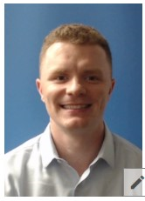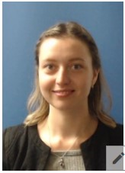

Neil Bernard, DPM Angelika Sheiman, DPM

**2nd Year Residents PGY-2**

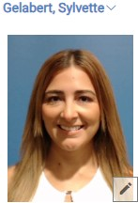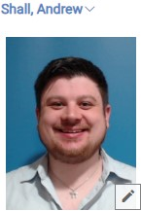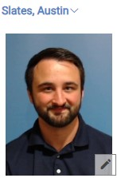

Sylvette Gelabert-Baez, DPM Andrew Shall, DPM Austin Slates, DPM

**1st Year Residents PGY-1**

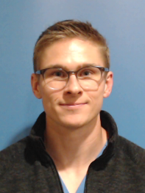 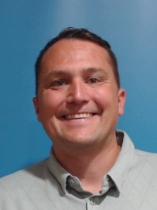 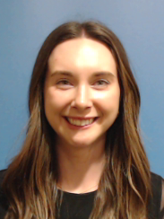 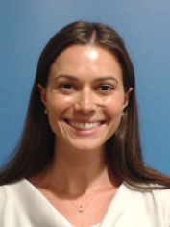

David Coffey, DPM Stephan Jokic, DPM Lauren Pekar, DPM Halle Strachan, DPM